
PURBANCHAL UNIVERSITY
Gomendra Multiple College
Faculty of Science and Technology

BookHub (Collibra)
IN PARITAL FULLFILLMNET OF THE REQUIREMENT OF BCA 5th SEMESTER

Submitted By:
Kushal Bhandari (350026)
Bishal Magar (350011)
Sandesh Bharati (350043)

Under the supervision of Mr. Kushal Niroula

Acknowledgment
This project documentation, prepared in November 2025, represents the result of a week of dedicated effort, collaboration, and continuous learning. Throughout the process, we faced challenges that helped us grow both technically and professionally, making the journey truly rewarding.
We would like to express our sincere gratitude to Dr. Rupak Khanal, College Chief of Gomendra Multiple College, for fostering a learning environment that encourages innovation, creativity, and practical application of knowledge.
Our heartfelt thanks also go to Mr. Vimal Rajbanshi, BCA Coordinator, for his constant support, timely guidance, and encouragement during the development phase.
A special note of appreciation goes to our mentor, Mr. Kushal Niroula, whose expertise in WebSocket technology and React-based interface design greatly contributed to the successful completion of BookHub (Collibra). His guidance helped us enhance the functionality and overall user experience of the project.
We extend our appreciation to Purbanchal University for introducing a practical and innovative curriculum that empowers students to apply academic concepts in real-world projects.
Lastly, we are also grateful to our friends and peers for their collaboration, suggestions, and motivation throughout the project’s development and testing stages.

ABSTRACT
Collibra is a dynamic BookHub platform developed to revolutionize access to arts and literature by addressing the limitations of traditional libraries and existing digital solutions. Originally conceptualized as an e-commerce platform for physical books, Collibra has evolved into a comprehensive digital ecosystem, set to launch by end-2026, offering seamless access to e-books and digital reading experiences.
The platform is built using React for an adaptive and responsive frontend, Node.js for a scalable backend, MySQL for secure and efficient data management, and WebSockets to enable real-time updates. It features two main interfaces — an Admin Panel for content management and a User Panel for browsing, bookmarking, and purchasing books.
Key features include real-time content synchronization, genre-based filtering, secure JWT authentication, and an intuitive user interface designed with a Slate Blue and Soft Coral color palette for an engaging visual experience.
This documentation presents the project’s problem statement, agile development methodology, system analysis, architecture, and technology stack, providing a detailed reference for both stakeholders and developers.
By enhancing accessibility for readers, expanding market opportunities for publishers, and offering a seamless, interactive user experience, Collibra aims to redefine the way literature is discovered, shared, and enjoyed in the digital age.

Contents
Chapter 1 | Introduction 1
1.1 Problem Statement 1
1.2 BookHub (Collibra) 2
1.3 Project Scope 4
1.4 Key Features 6
1.4.1 Admin Features 6
1.4.2 User Features 6
1.4.3 User-Friendly Interface 7
1.4.4 WebSocket Integration 7
Chapter 2 | Literature Review and Methodology 8
2.1 Literature Review 8
2.1.1 Traditional Methods 8
2.1.2 Modern Digital Solutions 8
2.1.3 Limitations of Existing Solutions 9
2.2 Methodology 9
2.2.1 Project Planning and Requirement Gathering 9
2.2.2 System Design and Architecture Planning 9
2.2.3 User Interface (UI Design) 10
2.2.4 Agile Development Approach 10
2.2.5 Implementation 10
2.2.6 Testing and Quality Assurance 11
2.2.7 Deployment and Feedback Loop 11
Chapter 3 | System Analysis 12
3.1 Requirement Gathering and Analysis 12
3.1.1 Stakeholder Engagement 12
3.1.2 Analysis of Findings 12
3.2 Functional Requirements 13
3.2.1 User Authentication and Authorization 13
3.2.2 Book Management (Admin) 13
3.2.3 Explore Books (User) 13
3.2.4 Search and Bookmark 14
3.2.5 Real-Time Updates 14
3.3 Non-Functional Requirements 14
3.3.1 Performance 14
3.3.2 Scalability 14
3.3.3 Security 14
3.3.4 Usability 15
3.3.5 Reliability 15
Chapter 4 | Architecture and Technology Stack 16
4.1 System Architecture 16
4.2 Data Flow 16
4.3 Technology Stack 16
4.3.1 Backend 17
4.3.2 Frontend 17
4.3.3 Database 17
4.4 UI Design and Color Codes 17
4.5 System Design 19
4.5.1 E-R Diagram 19
4.5.2 Schema Diagram 21
4.5.3 Use Case Diagram 22
4.5.4 Sequence Diagram 24
4.5.5 Data Flow Diagram 26
Chapter 5 | Implementation and Testing 29
5.1 Development Environment Setup 29
5.2 Coding 29
5.2.1 General Convention 30
5.2.2 JavaScript/Node.js Conventions 31
5.3 Best Practices 32
5.3.1 Readability 32
5.3.2 Maintainability 32
5.3.3 Testing 32
5.4 Security Practices 32
5.4.1 Input Validation 32
5.4.2 Authentication and Authorization 32
5.4.3 Data Protection 33
5.5 Hardware and software requirements 33
5.5.1 Hardware Requirements 33
5.5.2 Software Requirements 33
5.6 Implementation Details 33
5.6.1 Frontend Implementation 33
5.6.2 Backend Implementation 34
5.6.3 Database Setup 35
5.7 Testing Strategy 35
5.7.1 Unit Testing 35
5.7.2 Integration Testing 36
5.7.3 Black-Box Testing 36
5.7.4 White-Box Testing 36
5.7.5 Security Testing 37
5.7.6 Manual & UI Testing 37
5.7.7 Error Handling Tests 37
5.8 Project Scheduling 38
5.9. Gantt Chart 39
5.9 System in Action 39
5.9.1 Admin Panel 39
5.9.2 User Panel 42
Chapter 6 | Limitations and Future enhancements 43
6.1 Limitations 43
6.1.1 Limited User Authentication and Roles 43
6.1.2 Basic Search Functionality 43
6.1.3. No In-App Reading Progress Tracking 43
6.1.4. File Storage Constraints 43
6.1.5. No User Review or Ratings 43
6.2 Future Enhancements 44
6.2.1. User Authentication 44
6.2.2. Search and Recommendation System 44
6.2.3. In-App Reading Experience 44
6.2.4. Full Audiobook Integration 44
6.2.5. Analytics for Publishers 44
6.2.6. Mobile App 44
6.2.7. Multilingual and Accessibility Support 44
6.2.8. Admin Dashboard Analytics 45
6.2.9. Subscription Model 45
6.2.10. User Customization & Settings 45
Chapter 7 | Conclusion 46
7.1 Achievements 47
7.1.1 Technical Accomplishments 47
7.1.2 User Impact 47
7.2 Challenges and Learnings 48
7.2.1 Challenges 48
7.2.2 Learnings 48
7.3 Future Directions 48
Chapter 8 | References and Bibliography 50
8.1 References 50
8.2 Bibliography 51

Abbreviations
1, | SQL | Standard Query Language
2. | API | Application Programming Interface
3. | UI | User Interface
4. | CORS | Cross-Origin Resource Sharing
5. | CRUD | Create, Read, Update and Delete
6. | UI | User Interface
7. | ER | Entity Relationship
8. | DFD | Data Flow Diagram
9. | IDE | Integrated Development Environment
10. | npm | Node Package Manager
11. | CSS | Cascading Style Sheet
12. | RAM | Random Access Memory
13. | HDD/SDD | Hard Disk Drive/Solid State Drive
14. | OS | Operating System
15. | PDF | Portable Document Format
16. | JWT | JSON Web Token

Table of Figures
Figure 1: Admin Panel ER Diagram 19
Figure 2:User Panel ER Diagram 20
Figure 3: Schema Diagram 21
Figure 4: Admin Panel Use Case Diagram 22
Figure 5: User Panel Use Case Diagram 23
Figure 6: Admin Panel Sequence Diagram 24
Figure 7: User Panel Sequence Diagram 25
Figure 8: Level-0 Admin Panel DFD Diagram 26
Figure 9: Level 1 Admin Panel DFD Diagram 26
Figure 10: Level 2 Admin Panel DFD Diagram 27
Figure 11: Level 0 User Panel DFD Diagram 27
Figure 12: Level 1 User Panel DFD Diagram 28
Figure 13: Level 2 User Panel DFD Diagram 28
Figure 14: Project Scheduling 38
Figure 15: Gantt Chart 39
Figure 16: Admin Panel 39
Figure 17: Add Books 40
Figure 18: View Books 41
Figure 19: Front Page 42
Figure 20: Explore Page 42

Chapter 1 | Introduction

1.1 Problem Statement
The BookHub (Collibra) project was conceived to address persistent challenges in how readers, students, and publishers access, manage, and share literary content in the modern digital era. Despite technological advancements, traditional and existing digital library systems continue to face significant limitations in accessibility, engagement, and inclusivity. The key issues identified are as follows:
1. Limited Accessibility and Physical Constraints
- Access to literature is still heavily dependent on physical libraries, which restrict users based on location and operating hours.
- Individuals living in rural or remote areas face difficulties visiting physical libraries.
- Readers with disabilities or mobility challenges encounter barriers to accessing books physically.
- Fixed library hours and limited stock make it difficult for users to find desired books when needed.
2. Geographical and Economic Inequality
- A vast number of readers, especially in developing regions, remain deprived of literary resources.
- Many areas lack well-equipped libraries or affordable bookstores.
- High costs of printed books, coupled with shipping expenses, create financial barriers for students and low-income users.
- Paid digital platforms, such as subscription-based e-libraries, often remain inaccessible due to recurring fees.
3. Absence of Real-Time Interaction and Dynamic Updates
- Most digital libraries operate on static databases, offering little to no real-time engagement.
- Users are not notified when new books, events, or updates are added.
- This lack of dynamic updates discourages regular usage and reduces user engagement.
- Authors and publishers also struggle to promote new releases effectively without real-time visibility.
4. Lack of User-Centered and Interactive Features
- Existing platforms often fail to deliver a personalized and interactive reading experience.
- Features such as bookmarks, personalized recommendations, and reading history are either limited or absent.
- There are few options for social interaction, such as commenting, reviewing, or participating in virtual book events.
- Readers cannot easily explore related content or connect with authors and publishers directly.
5. Insufficient Support for Authors and Publishers
- Writers and publishers face growing challenges in promoting and distributing their content effectively.
- Many digital platforms prioritize large publishing houses, leaving independent authors with limited exposure.
- Publishers lack tools to create, manage, or analyze their own digital book collections.

1.2 BookHub (Collibra)
Collibra is a digital platform designed to provide seamless access to e-books for arts and literature events. It features a React-based frontend with components like BookCard.js (for book display and bookmarking), Navbar.js (with search and bookmark counter), and an admin panel for content management. The platform uses Node.js for backend logic, MySQL for data storage, and WebSockets for real-time updates. It’s under development with a planned launch by the end of 2025, including a mobile app.
Below are the key aspects of the platform, explained in detail:
- Origin and Evolution:
- Collibra set to launch by end-2026, as an e-commerce platform focused on developing reading book culture in the digitalized form.
- Today, Collibra serves as a bridge between readers, publishers, and authors, providing a centralized solution for digital literature access and engagement.
- Core Purpose:
- Collibra aims to remove physical and financial barriers, making literature accessible to users worldwide.
- With features like real-time updates, bookmarking, and intuitive navigation, the platform encourages users to actively explore and interact with content.
- It supports publishers and authors by providing a digital marketplace to showcase their work and reach a global audience.
- Dual Interface Design:
- Admin Panel: A React-based interface allows administrators to manage books (add, view, update, delete) with real-time notifications to users.
- User Panel: A React-based interface enables users to explore books, filter by genre, bookmark favorites, and access informational pages.
- The dual-panel design ensures that admin actions are seamlessly reflected in the user experience, maintaining a dynamic platform.
- Support for Multiple Stakeholders:
- Readers: Gain access to a large catalog of e-books and audiobooks, with features like genre filtering, PDF downloads, and bookmarking.
- Publishers: Can showcase their books digitally, reach a wider audience, and utilize library setup services for organizations.
- Authors: Benefit from increased visibility, especially independent authors who can promote their work through the platform’s event ticketing feature.
- Innovative Features:
- Real-time updates ensure users are immediately informed of new books or changes, improving engagement.
- The platform integrates e-books offering a holistic solution.

1.3 Project Scope
The scope of the Collibra project is clearly defined and strategically aligned to meet the needs of both content managers and end-users. The project focuses on creating a digital eLibrary with two main interfaces:
- Admin Panel:
- Enables administrators to manage book data, images, and PDFs through a responsive interface.
- Supports full CRUD (Create, Read, Update, and Delete) operations on book entities.
- Sends real-time updates to users upon modification of book data.

- User Panel:
- Explore books with a grid layout and genre filtering.
- View book details in a modal (includes description, publication year, etc.).
- Read or download book PDFs directly from the platform.
- Bookmark books and manage them on a dedicated page.
- Access informational pages (Home, About, Terms, Privacy).

- Real-Time Updates:
- Ensures that any content modification performed by admins is reflected instantly on the user’s Explore page.
- Enhances platform interactivity and keeps users engaged with fresh content.

- Backend Integration:
- Built with Node.js/Express, MySQL, and WebSockets for data storage, file management, and real-time updates.
- Ensures synchronized communication between admin actions and user views, particularly for the Explore page.

1.4 Key Features

1.4.1 Admin Features
- Book Management:
- Add new books with details including title, author, genre, description, publication year, cover image, and PDF file.
- Update existing book information to keep content current.
- Delete books from the platform as needed.
- Real-time Notifications:
- Real time update via WebSockets when admins modify book information (e.g., add, update, or delete).

1.4.2 User Features
- Book Exploration:
- Browse books displayed in a grid layout.
- Filter books by genre for easier navigation.
- Book Details:
- View comprehensive book information (e.g., description, publication year) in a modal popup.
- Read & Download:
- Read books online directly on the platform.
- Download PDF versions of books for offline access.
- Bookmarking:
- Bookmark books to save them for later access.
- Manage bookmarked books on a dedicated saved list page.
- Informational Pages:
- Access standard pages including Home, About, Terms, and Privacy for platform information.
- Real-time Search:
- Search for books by name, author, or partial letters using a search bar.
- Receive efficient, real-time results through debounced API calls.

1.4.3 User-Friendly Interface
- Intuitive Design:
- Features a clean, minimal interface with a Slate Blue and Soft Coral color scheme.
- Ensures accessibility for users of all technical levels.
- Responsive Layout:
- Built with React for seamless adaptation across devices (desktops, tablets, mobile phones).

1.4.4 WebSocket Integration
- WebSocket Integration:
- Reflects admin changes (e.g., adding new books) instantly on the user-facing explore page.
- Live Search:
- Provides real-time search results in the Navbar.js component using debouncing and API queries.

Chapter 2 | Literature Review and Methodology

2.1 Literature Review
The evolution of digital libraries has been well documented in academic research and industry studies. This section reviews key concepts, platforms, and technologies that form the foundation for the BookHub (Collibra) project. The review focuses on the transformation of traditional libraries, limitations in current digital library platforms, and emerging trends in real-time systems and interactive user design.

2.1.1 Traditional Methods
- Physical Libraries: Traditional libraries require users to visit physical locations, borrow books, and return them, which is time-consuming and inconvenient.
- Limited Inventory: Physical collections are finite, often resulting in long waitlists for popular titles.
- Accessibility Issues: Users in remote areas or with mobility constraints face difficulty accessing physical libraries.

2.1.2 Modern Digital Solutions
- Digital Platforms: Services such as Kindle, Google Books, and OverDrive provide access to e-books and audiobooks, enabling features like search, purchase, and offline reading.
- User Features: Some platforms allow bookmarking, annotations, and cloud storage. However, most lack real-time content updates, limiting dynamic interaction.
- Market Focus: Current solutions primarily cater to readers, offering minimal tools for publishers or authors to expand their reach or interact with audiences effectively.

2.1.3 Limitations of Existing Solutions

- No Real-Time Updates: Users must manually check for new books, reducing engagement.
- Basic Bookmarking: Bookmarking features are often limited, lacking intuitive management tools.
- Publisher Challenges: Few platforms help publishers reach broader markets or offer integrated services like event ticketing.
- Lack of Comprehensive Services: No platform combines e-books, audiobooks, event ticketing, and library setup services effectively.

2.2 Methodology
The development of Collibra follows a User-Centered Agile Methodology, focusing on iterative development and feedback loops. The methodology incorporates best practices from both software engineering and library sciences, ensuring the final platform are technologically robust and user-friendly.

2.2.1 Project Planning and Requirement Gathering
- The project began with a thorough analysis of existing digital platforms and interviews with stakeholders, including students, authors, librarians, and independent publishers.
- Key requirements were documented, categorized into functional and non-functional specifications, and aligned with user personas and use cases.

2.2.2 System Design and Architecture Planning
A modular and scalable architecture was selected, comprising the following components:
- Frontend: React.js for both admin and user interfaces to ensure component reusability and maintainability.
- Backend: Node.js with Express.js for RESTful APIs and WebSocket support.
- Database: MySQL for relational data management, ensuring ACID compliance.
- Real-Time Engine: WebSocket server integrated into the backend for live updates.

2.2.3 User Interface (UI Design)
- Wireframes and prototypes were created using Figma to model user journeys.
- UI elements were designed to be visually cohesive, using a consistent color scheme, typography, and responsive layout to support access on both desktop and mobile devices.

2.2.4 Agile Development Approach
The project was divided into sprints of 1–2 weeks, each targeting a specific feature set:
- Sprint 1: Admin panel (CRUD operations for books)
- Sprint 2: User panel (Explore page, modal view, bookmarking)
- Sprint 3: WebSocket integration for real-time updates
- Sprint 4: Static informational pages (Home, About, Terms, Privacy)
Regular stand-ups and sprint reviews were held to evaluate progress and gather feedback for the next iteration.

2.2.5 Implementation
- Book Management System: Developed with robust validation and upload features for cover images and PDFs.
- Explore and Bookmarking Features: Implemented using state management (React Context API) and efficient data fetching techniques.
- Real-Time Update System: WebSocket-based communication to notify users of new or updated book entries instantly.
- Security Measures: Implemented basic authentication and backend validation to protect against unauthorized access and SQL injection.

2.2.6 Testing and Quality Assurance
- Conducted unit testing for backend routes and components.
- Performed manual and automated UI testing using tools like Jest and React Testing Library.
- User acceptance testing (UAT) was conducted with testers, including librarians, readers, authors and among with friends, to validate the platform’s usability.

2.2.7 Deployment and Feedback Loop
- Configured the user panel (React frontend, e.g., Explore.jsx, BookCard.js, Navbar.js) to run using npm start, leveraging create-react-app for hot reloading and rapid iteration.
- Set up the admin panel (React frontend, e.g., AdminDashboard.jsx, AddBookForm.jsx) using a separate React instance (e.g., PORT=3001 npm start) to isolate admin functionality.
- Integrated a G-mail and Contact No. in Contact Us on the user panel, allowing users to submit suggestions.

Chapter 3 | System Analysis

3.1 Requirement Gathering and Analysis
This phase focused on identifying and analyzing the needs of all stakeholders—readers, event attendees, admins, and publishers—to ensure Collibra delivers a comprehensive, user-friendly, and efficient digital library experience.

3.1.1 Stakeholder Engagement
Stakeholders include users (readers, author, event attendees), admins, and developers. Requirements were gathered via:
- Admins: Needed tools to manage books efficiently, with a focus on ease of use.
- Users: Wanted an intuitive interface to explore, bookmark, and read books.
- Publishers: Sought a platform to showcase their books and reach a global audience.
- Methods: Interviews, surveys, and questionnaire were used to gather requirements.
- Feedback Collection: Focused on pain points like fragmented access and complex interfaces in existing platforms.

3.1.2 Analysis of Findings
Findings emphasized the need for a responsive UI, real-time updates, secure authentication, and scalable database design. Users prioritized intuitive navigation (Navbar.js) and fast search, while admins needed robust tools (adminPanel).
- Admin Needs: A simple interface for CRUD (Create, Read, Update, and Delete) operations with real-time user notifications.
- User Needs: Intuitive UI, real-time updates, and features like bookmarking and genre filtering.
- Publisher Needs: Digital marketplace to expand reach and library setup services.
- Technical Needs: High performance, security, and scalability to handle growing user bases.
- Common Themes: Need for a unified platform, intuitive UI, and real-time content updates.

3.2 Functional Requirements

3.2.1 User Authentication and Authorization
- Admins can access the adminPanel using username and password (i.e. Username: ‘admin’ and Password: ‘admin123’)
- JWT-based admin authentication for secure access to adminPanel.
- Users access the userPanel publicly without authentication.

3.2.2 Book Management (Admin)
- Add Book: Input book details and upload cover image and PDF, stored in uploads/.
- View Books: Display all books in a table with edit/delete options.
- Update Book: Modify book details, including replacing files, with file cleanup for old uploads.
- Delete Book: Remove a book and its associated files from the server.

3.2.3 Explore Books (User)
- View books in a grid layout on the Explore page.
- Filter books by genre using a dropdown (e.g., Fiction, Thriller, Self-Help, and so on).
- View book details in a modal with options to read or download the PDF.

3.2.4 Search and Bookmark
- Bookmark a book with a toggle button on the book card, stored in local storage.
- View bookmarked books on the Bookmarks page in a grid layout.
- Remove bookmarks with a single click, updating local storage.
- Real-time search by book name, author, or keywords using API queries.

3.2.5 Real-Time Updates
- Admin actions (add, update, delete) trigger WebSocket notifications.
- The Explore page automatically refreshes to reflect changes within 1 second.

3.3 Non-Functional Requirements

3.3.1 Performance
- Page load time under 2 seconds for the Explore page.
- WebSocket updates delivered within 1 second.

3.3.2 Scalability
- Support up to 10,000 concurrent users via Node.js clustering and MySQL optimization.
- Database optimized with indexes (e.g., on genre column).

3.3.3 Security
- Secure file uploads using Multer to prevent malicious files.
- JWT for admin authentication.
- MySQL credentials stored securely (future enhancement: use environment variables).

3.3.4 Usability
- Intuitive UI with a sidebar for genre filtering and a grid layout for books.
- Responsive design for mobile and desktop users.

3.3.5 Reliability
- Backend server uptime of 99.9%.
- Graceful error handling for failed API requests or WebSocket disconnections.

Chapter 4 | Architecture and Technology Stack

4.1 System Architecture
Collibra adopts a three-tier architecture:
- Presentation Layer: React-based frontend for user interaction, split into an Admin Panel for book management and a User Panel for content exploration and ticketing.
- Business Logic Layer (Application Layer): Node.js backend with Express for real-time WebSocket communication, and Multer for file management.
- Data Access Layer: MySQL database for storing user data, book metadata, bookmarks, with file storage for PDFs and images.

4.2 Data Flow
- Admin adds a book via the adminPanel.
- Backend saves the book to MySQL and stores files in uploads/.
- WebSocket broadcasts a BOOKS_UPDATED message to all connected clients.
- User’s explore.jsx in userPanel receives the message, re-fetches books, and updates the UI.

4.3 Technology Stack
- Backend: Node.js with Express for APIs and WebSocket for real-time updates.
- Frontend: React with components like BookCard.js, Navbar.js, and AboutUs.jsx.
- Database: MySQL for robust data management.
- Axios: For API calls.
- CSS: Custom styles (Slate Blue/Soft Coral, animations).

4.3.1 Backend
The backend, built with Node.js and Express.js, handles business logic, API requests, and real-time communication. Socket.IO enables live updates (e.g., new book alerts), while Multer manages PDF and image uploads. JWT authentication secures admin access, with middleware for validation and error handling, ensuring a scalable and secure system.

4.3.2 Frontend
The frontend of the Collibra application, developed with React.js, delivers a responsive and intuitive user interface for both admin and user interactions. Key components include BookCard.js (displays book details with bookmarking functionality), Navbar.js (handles navigation and search), and explore.jsx (facilitates content browsing). Supporting libraries such as React Router enable single-page navigation, custom CSS with a Slate Blue and Soft Coral color scheme ensures visually appealing styling, and react-icons enhance the UI with visual elements. Key features include genre filtering, modal previews for book details, and real-time updates driven by WebSocket integration.

4.3.3 Database
The database, implemented with MySQL, stores structured data in tables for Users (admin credentials include username and password) and Books (metadata such as title, author, genre). Direct MySQL queries ensure efficient data access and manipulation. An optimized schema design with indexes on frequently queried fields (e.g., book title, author) supports fast queries, particularly for real-time search functionality. Regular backups maintain reliability and protect against data loss.

4.4 UI Design and Color Codes
The UI design focuses on simplicity and readability, using a consistent color scheme:
- Background Colors:
  - Pure White (#FFFFFF): Used for book cards and main content backgrounds (.book-card, .main-content).
  - Light Gray (#F2F2F2): Used for the Explore page container and modal backgrounds (.explore-container, .book-details-modal).
- Text Colors:
  - Dark Charcoal (#2E2E2E): Used for book titles, authors, and descriptions (.book-card h3, .book-card p, .book-details-modal p).
- Button and Accent Colors:
  - Slate Blue (#4A90E2): Primary color for buttons (e.g., “Read”, “Download”, “View Details”) (.book-actions button, .view-details-button, .modal-buttons button).
  - Darker Slate Blue (#357ABD): Hover state for buttons (.book-actions button:hover, .view-details-button:hover).
  - Soft Coral (#FF6B6B): Used for bookmark icons when bookmarked (.bookmark-button.bookmarked) and modal close button hover (.modal-close-symbol:hover).
- Other UI Elements:
  - Red (#e74c3c): Used for the remove bookmark button (.remove-bookmark in bookmarks.jsx).
  - Darker Red (#c53030): Hover state for remove bookmark button (.remove-bookmark:hover).
  - Light Red (#f8d7da): Background for remove bookmark button hover (.remove-bookmark:hover in bookmarks.jsx).

Usage in UI
- Explore Page: Background (#F2F2F2), book cards (#FFFFFF), text (#2E2E2E), buttons (#4A90E2 to #357ABD on hover).
- Bookmarks Page: Background (#FFFFFF), bookmark button (#FF6B6B when active).
- Modal: Background (#F2F2F2), close button hover (#FF6B6B).

4.5 System Design
System Design refers to the process of defining the architecture, components, modules, interfaces, and data structures of a system to meet the specified requirements. For Collibra, the system design phase translates the requirements gathered into a blueprint for building the platform. It encompasses the creation of diagrams and models that illustrate how the system’s components interact, how data is structured, and how processes flow. This ensures that the development team has a clear roadmap for implementation, addressing both functional (e.g., book search) and non-functional (e.g., scalability, performance) requirements.

4.5.1 E-R Diagram

4.5.1.1 Admin Panel

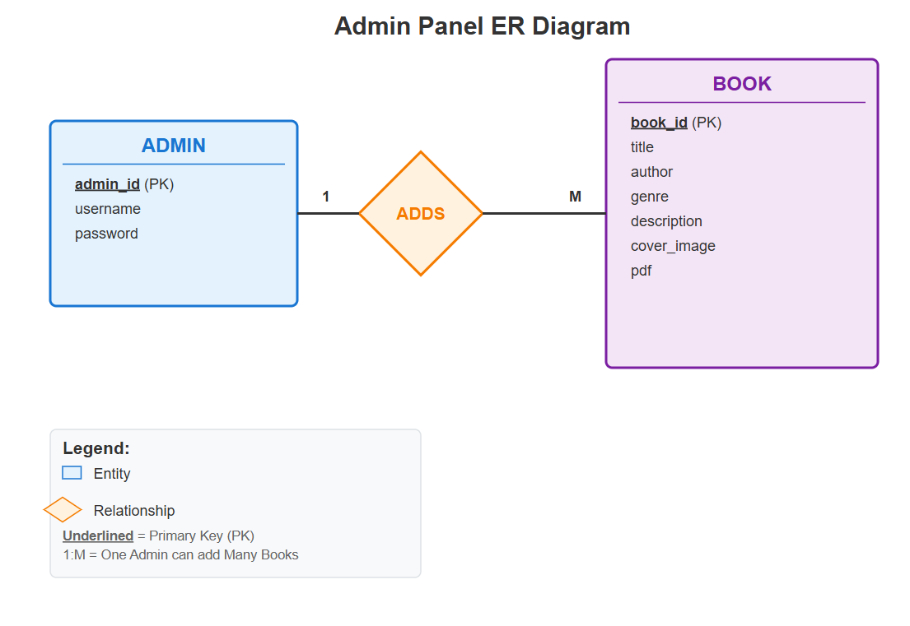
Figure 1: Admin Panel ER Diagram

4.5.1.2 User Panel

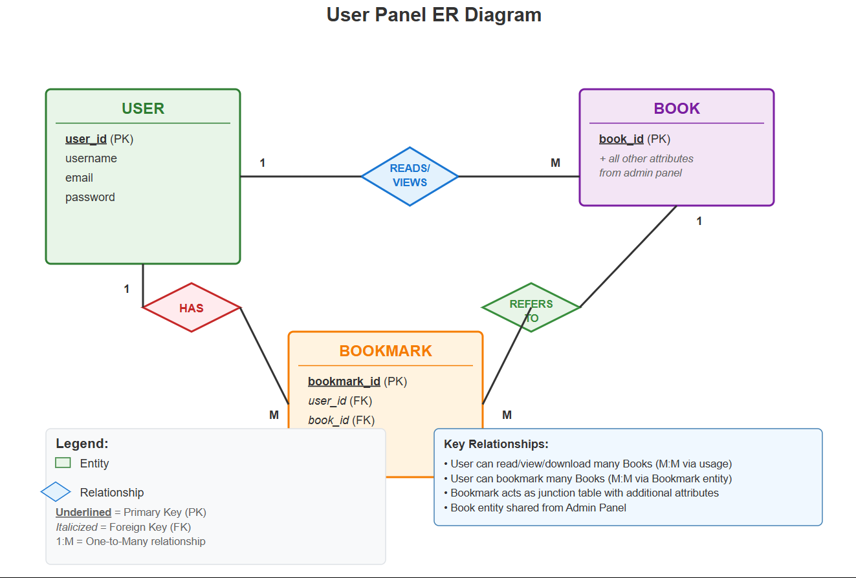
Figure 2:User Panel ER Diagram

4.5.2 Schema Diagram

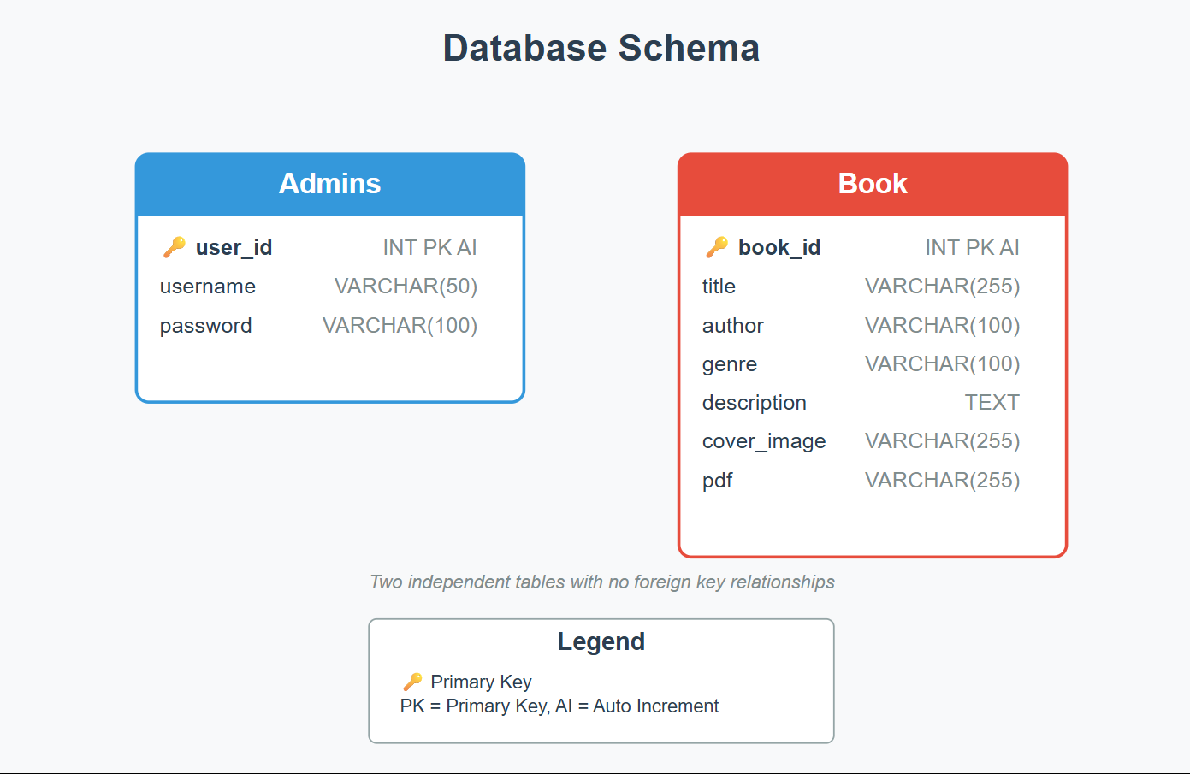
Figure 3: Schema Diagram

4.5.3 Use Case Diagram

4.5.3.1 Admin Panel
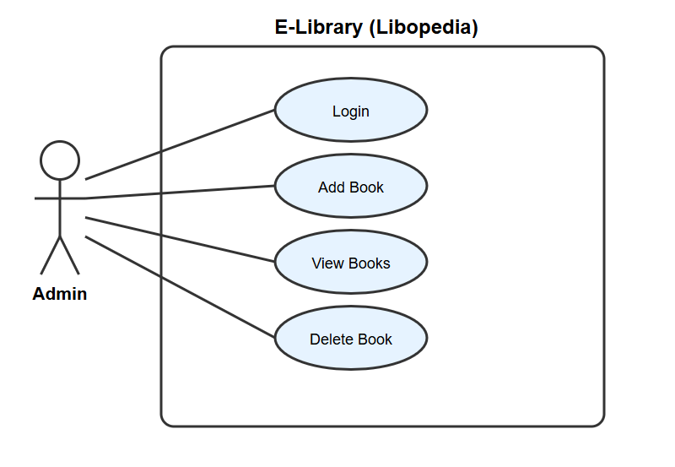
Figure 4: Admin Panel Use Case Diagram

4.5.3.1 Admin Panel
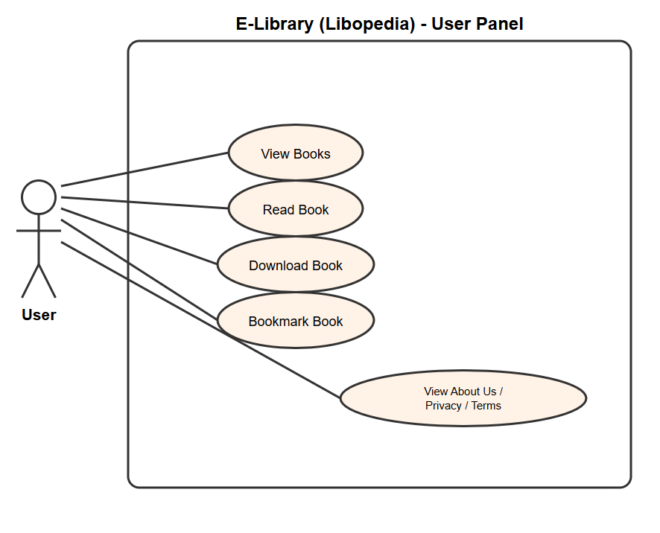
Figure 5: User Panel Use Case Diagram

4.5.4 Sequence Diagram

4.5.4.1 Admin Panel
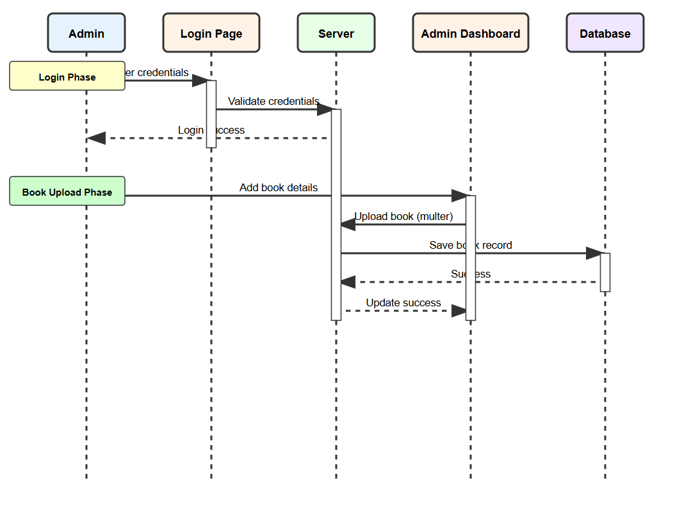
Figure 6: Admin Panel Sequence Diagram

4.5.4.2 User Panel
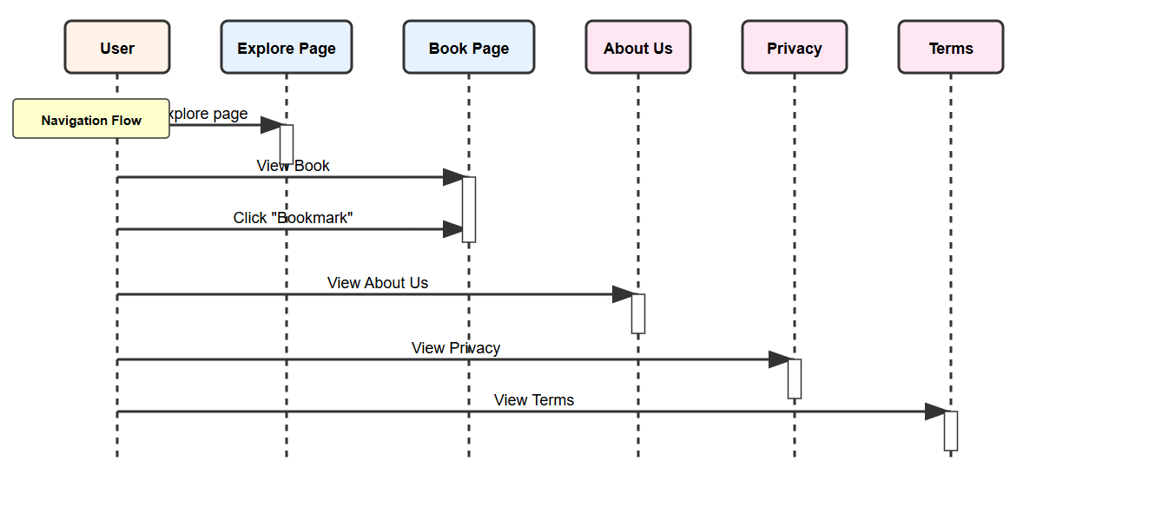
Figure 7: User Panel Sequence Diagram

4.5.5 Data Flow Diagram

4.5.5.1 Admin Panel
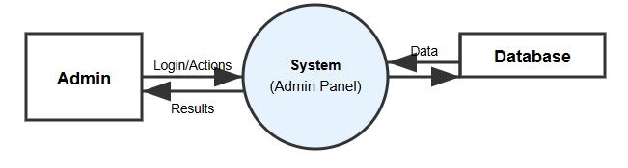
Figure 8: Level-0 Admin Panel DFD Diagram
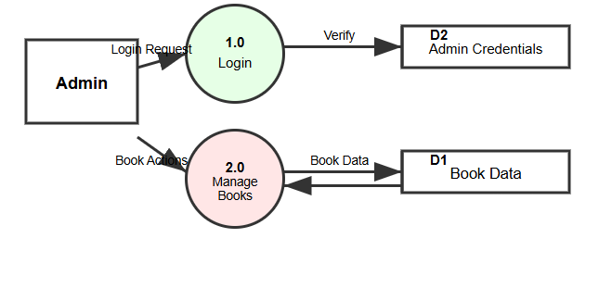
Figure 9: Level 1 Admin Panel DFD Diagram

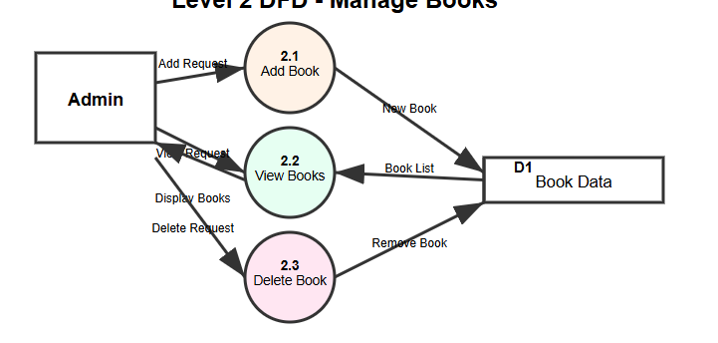

Figure 10: Level 2 Admin Panel DFD Diagram

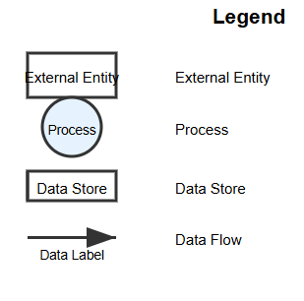

4.5.5.1 User Panel
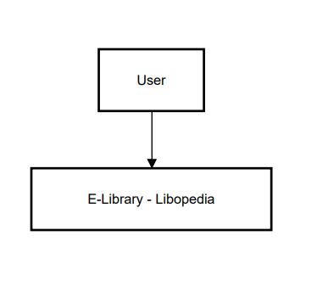
Figure 11: Level 0 User Panel DFD Diagram

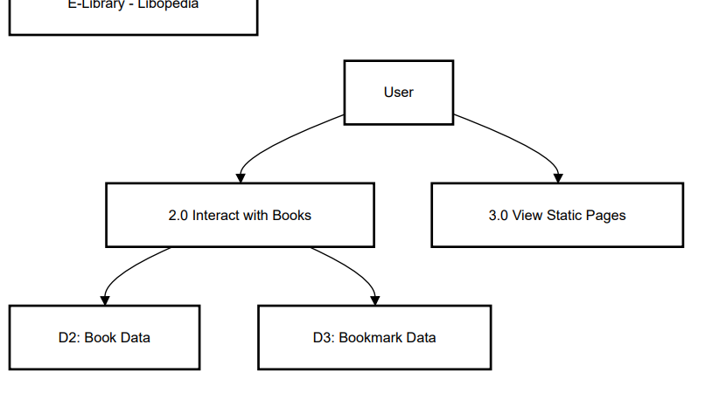
Figure 12: Level 1 User Panel DFD Diagram

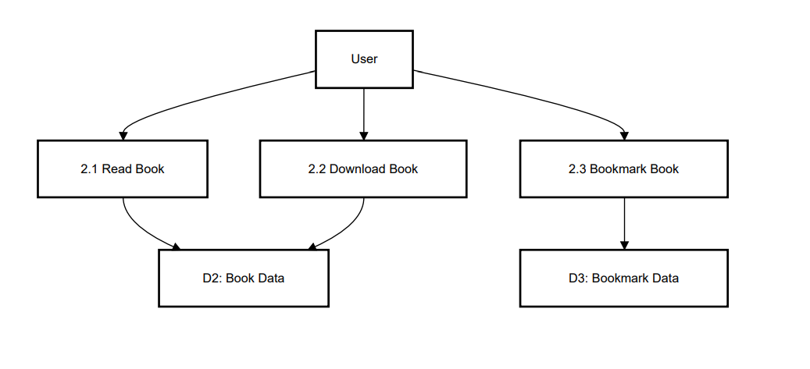
Figure 13: Level 2 User Panel DFD Diagram

Chapter 5 | Implementation and Testing
The implementation focused on translating the architectural design into working components, integrating real-time communication, and validating the functionality through rigorous testing practices.

5.1 Development Environment Setup
The development environment was configured to support Collibra’s tech stack, ensuring efficient coding, debugging, and version control.
- Node.js and npm:
- Installed Node.js (v18.x) and npm (v9.x) for managing backend services (Node.js/Express) and frontend dependencies (React).
- Used to install packages like express, socket.io, react, and axios.
- MySQL:
- Installed MySQL (v8.x) as the database management system.
- Configured a local MySQL server for development and testing, with a Collibra database.
- Visual Studio Code:
- Used Visual Studio Code as the primary IDE for code editing and debugging.
- Extensions installed: Prettier (for code formatting), MySQL (for database queries), and Live Server (for frontend preview).
- Git:
- Used Git for version control, hosted on GitHub.

5.2 Coding
The coding practices for Collibra ensured a maintainable, scalable, and readable codebase, adhering to industry-standard conventions tailored to JavaScript, React, and Node.js.

5.2.1 General Convention

5.2.1.1 Consistent Naming Convention
  - Use camelCase for variables and functions (e.g., fetchBooks, bookTitle).
  - Use PascalCase for React components and classes (e.g., BookCard, AdminDashboard).
  - Use UPPER_SNAKE_CASE for constants (e.g., API_BASE_URL).

5.2.1.2 Code Comments
  - Write clear comments to explain complex logic (e.g., WebSocket event handling).
  - Use JSDoc comments for JavaScript functions and React components (e.g., /** Fetches book list from API */).
  - Document API endpoints in Express routes (e.g., // POST /api/books - Add a new book).

5.2.1.3 Indentation and Spacing
  - Use 2 spaces per indentation level in JavaScript and React files.
  - Ensure consistent spacing around operators (e.g., let count = 1 + 2;).
  - Use Prettier for automatic formatting to maintain consistency.

5.2.1.4 File and Folder Structure
Organized files by functionality:
- Frontend (/client): /src/components (e.g., BookCard.js, Navbar.js), /src/pages (e.g., Explore.jsx, AdminDashboard.jsx), /src/api (API calls).
- Backend (/server): /routes (e.g., books.js, auth.js), /models (e.g., User.js, Book.js), /controllers (business logic).
- Database (/server/db): /migrations (Sequelize migrations), /seeds (test data).
- Used descriptive file names (e.g., BookController.js, ExplorePage.jsx).

5.2.2 JavaScript/Node.js Conventions

5.2.2.1 Function and Component Design
- Use camelCase for function names (e.g., handleBookSubmit).
- Keep functions and components small, following the Single Responsibility Principle (e.g., BookCard.js handles book display only).
- Use meaningful parameter names (e.g., bookData in addBook(bookData)).

5.2.2.2 Error Handling
- Use try-catch blocks in async functions (e.g., API routes, file uploads).
- Log errors using a logging library for debugging.
- Return user-friendly error messages (e.g., res.status(400).json({ error: 'Invalid file format' })).

5.2.2.3 Database Queries
- Use Sequelize ORM for MySQL queries, ensuring readable and secure operations.
- Example: Books.findAll({ where: { genre } }) for filtering books.

5.3 Best Practices

5.3.1 Readability
Used descriptive names (e.g., toggleBookmark, fetchBookDetails) and structured code with clear comments to enhance understanding.

5.3.2 Maintainability
Built modular components (e.g., reusable BookCard.js) and refactored code regularly using ESLint to eliminate code smells.

5.3.3 Testing
Wrote unit tests for critical functions (e.g., API endpoints, bookmark logic) and used Jest for automated testing to ensure code reliability.

5.4 Security Practices

5.4.1 Input Validation
  - Validated all user inputs (e.g., book title, file uploads) to prevent XSS and SQL injection.
  - Used libraries like express-validator for backend validation (e.g., check('title').notEmpty()).
  - Implemented client-side validation in React forms (e.g., required fields, file type checks).

5.4.2 Authentication and Authorization
  - Used JWT for secure authentication, verifying admin (role: 'admin') for protected routes (e.g., /api/admin/books).
  - Implemented role-based access control (RBAC) to restrict admin panel access.

5.4.3 Data Protection
  - Stored sensitive file URLs (cover_page, pdf_url) securely in the database.

5.5 Hardware and software requirements

5.5.1 Hardware Requirements
PROCESSOR | Intel Core i-7100
HDD/SSD | 256 GB.
RAM | Minimum 4GB

5.5.2 Software Requirements
OS | Windows 8 or Above (32 or 64 bit)
Database | Microsoft SQL Server 2011 and above
Other Software | VS Code, Node.js, extensions

5.6 Implementation Details
The Collibra platform was developed iteratively, with modular components integrated and tested at each phase. The project used Git for version control, with local environments for development and testing.

5.6.1 Frontend Implementation

5.6.1.1 Admin Panel
- Built with React.js using a component-based architecture.
- Implemented CRUD operations:
  - Add Book: Form in AddBookForm.jsx submits book details (title, author, genre, description, cover page, PDF) via POST /api/admin/books using Axios.
  - View Books: BookList.jsx fetches books via GET /api/admin/books and displays them in a table.
  - Update Book: EditBookForm.jsx submits changes via PUT /api/admin/books/:id.
  - Delete Book: Button in BookList.jsx sends DELETE /api/admin/books/:id
- Integrated Socket.IO-client for real-time notifications (e.g., socket.on('book_added', refreshBookList)).
- Styled with CSS, using Slate Blue and Soft Coral colors, with animations (e.g., pulsing bookmark counter in AdminNavbar.js).

5.6.1.2 User Panel
- Developed a responsive grid layout in Explore.jsx for book exploration, using BookCard.js to display book details (title, author, genre, cover image).
- Built a filtering system based on genre tags, fetching filtered books via GET /api/books?genre=.
- Implemented bookmarking with persistent storage (localStorage synced with Bookmarks table) and a dynamic counter in Navbar.js.
- Created a modal view (BookDetailsModal.jsx) for book details, with PDF preview and download buttons linked to pdf_url.

5.6.2 Backend Implementation
- Built with Node.js and Express.js for RESTful API endpoints (e.g., /api/books, /api/auth).
- Used Multer for handling file uploads (PDFs and cover images), storing files in a cloud service (e.g., AWS S3) and saving URLs in the Books table.
- Integrated Socket.IO for real-time communication, emitting events (book_added, book_updated, book_deleted) to update the user interface.

5.6.3 Database Setup
- Created tables in MySQL:
  - Users: id, username, email, password, role, created_at.
  - Books: id, title, author, genre, description, cover_page, pdf_url, type, created_at.
- Added indexes on searchable fields (title, author, genre) for efficient queries.
- Used Sequelize migrations to manage schema changes and seed data for testing.

5.7 Testing Strategy
A comprehensive testing approach ensured Collibra was reliable, functional, and user-friendly, using unit, integration, manual/UI, and error handling tests.

5.7.1 Unit Testing
- Tested individual functions (e.g., API responses, input validation, database queries)
- Sample Test Cases:
  - Book Submission: Verified empty fields return errors (expect(res.status).toBe(400)).
  - File Upload: Checked file size (< 10MB) and format (PDF, PNG/JPEG).
  - Genre Filter: Ensured GET /api/books?genre=Fiction returns correct books.
  - Bookmark Toggle: Tested bookmark addition/removal updates Bookmarks table.

5.7.2 Integration Testing
- Tested module interactions, such as book uploads appearing in the user panel.
- Verified WebSocket events update Explore.jsx in real-time when admins add/update/delete books.
- Ensured API-to-database flow (e.g., POST /api/books → Books table → GET /api/books).

5.7.3 Black-Box Testing
- Login: Entered valid/invalid username-password pairs on /admin/login. Expected: Valid credentials redirect to dashboard; invalid credentials show an error.
- Add Book: Submitted a book form with details (title, author, genre, description, cover image, PDF). Expected: Book appears in explore.jsx and database.
- View Books: Clicked “View Books” on the admin dashboard. Expected: All books listed correctly.
- Update Book: Edited a book’s title. Expected: Updated title reflects in explore.jsx instantly.
- Delete Book: Deleted a book. Expected: Book removed from explore.jsx and database.

5.7.4 White-Box Testing
- Admin Panel Logic:
- Login Endpoint (POST /api/auth/admin/login): Tested valid/invalid JWT generation, role validation (role: 'admin'). Edge case: Missing password field.
- Add Book (POST /api/admin/books): Tested Multer file upload limits (e.g., 10MB), duplicate title handling. Edge case: Invalid file format (e.g., .txt).
- WebSocket Events: Tested book_added, book_updated, book_deleted emissions. Edge case: Multiple admins adding books simultaneously.

- User Panel Logic:
- Search Function: Tested search functionality to ensure if it works properly or not

- Database Operations:
- Tested Sequelize CRUD operations (e.g., books.create, books.delete, admin.add).
- Edge case: Database disconnection during book addition.

5.7.5 Security Testing
- SQL Injection: Malicious inputs (e.g., '; DROP TABLE Users; --) sanitized by Sequelize, preventing unauthorized access.
- File Upload Security: Malicious files (e.g., .exe) rejected by Multer, ensuring only PDF/images allowed.

5.7.6 Manual & UI Testing
- Verified:
  - Buttons and forms (e.g., “Add Book,” “Bookmark”) work correctly.
  - Real-time update when books are added.
  - Bookmarks persist across sessions and update the Navbar.js counter.
  - PDF previews and downloads function via pdf_url.

5.7.7 Error Handling Tests
- Simulated failures:
  - Backend crashes (e.g., database disconnection) return user-friendly messages.
  - Invalid file uploads (e.g., wrong format) display errors.
  - Unauthorized actions (e.g., non-admin accessing /api/admin/books) return 403.
- Tested edge cases like duplicate book titles or missing form fields.

5.8 Project Scheduling

Figure 14: Project Scheduling
5.9. Gantt Chart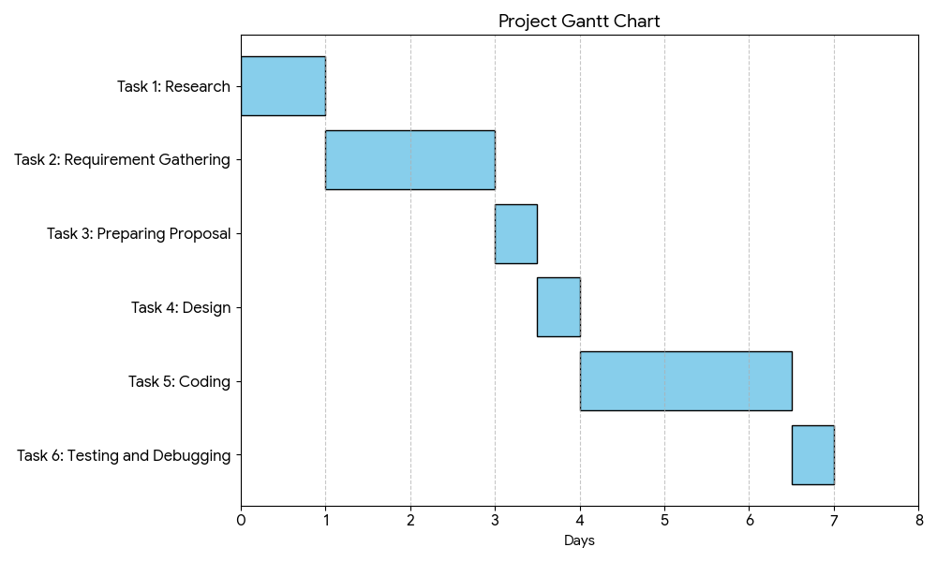
Figure 15: Gantt Chart

5.9 System in Action

5.9.1 Admin Panel

5.9.1.1 Login Form
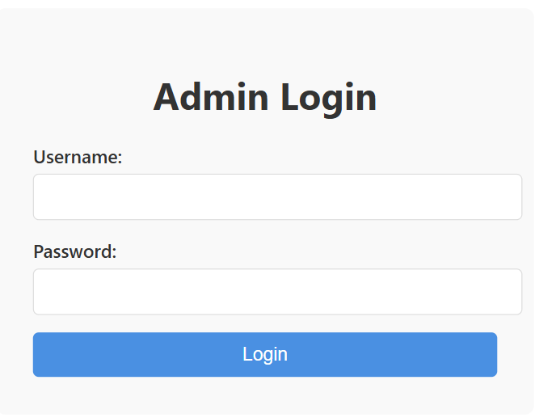
Figure 16: Admin Panel

5.9.1.2 Add Books
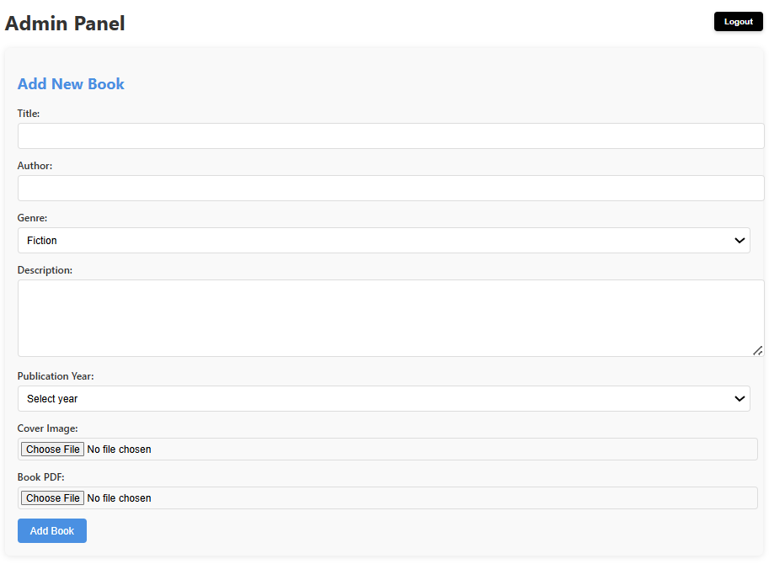

Figure 17: Add Books

5.9.1.3 View Books
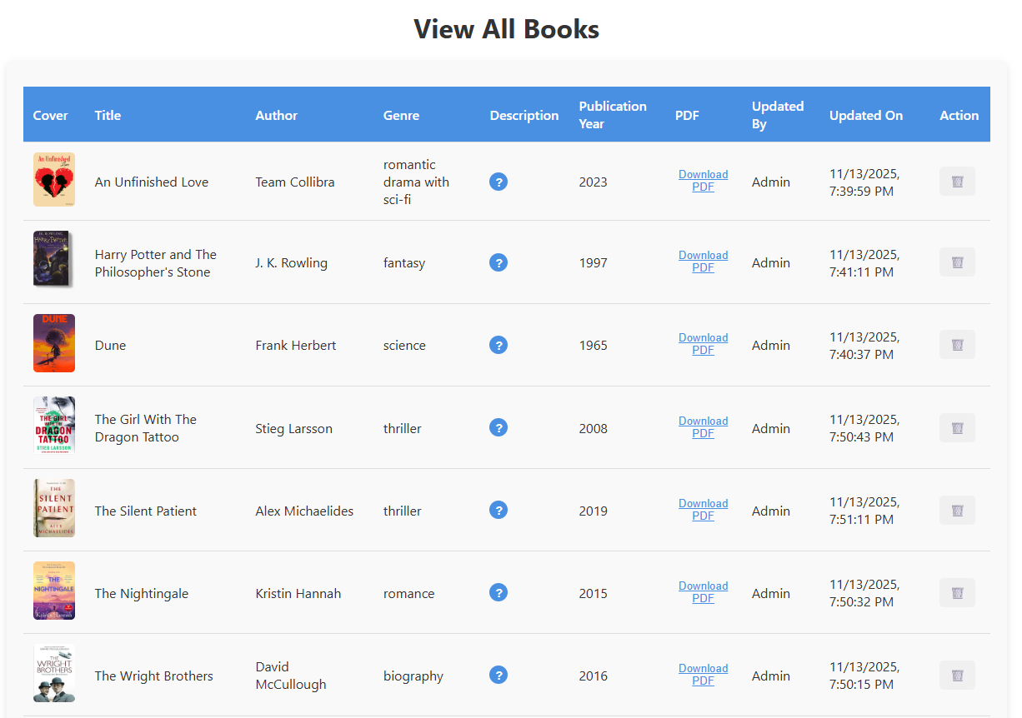
Figure 18: View Books

5.9.2 User Panel

5.9.2.1 Front Page
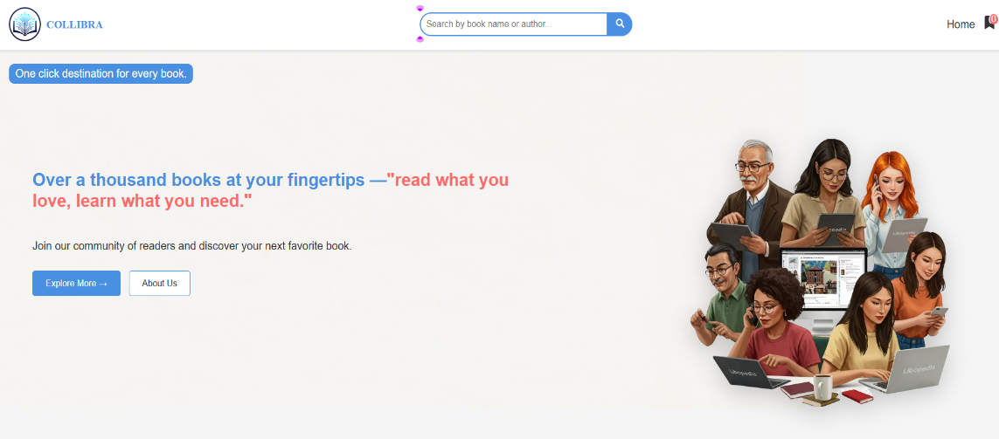
Figure 19: Front Page

5.9.2.2 Explore Page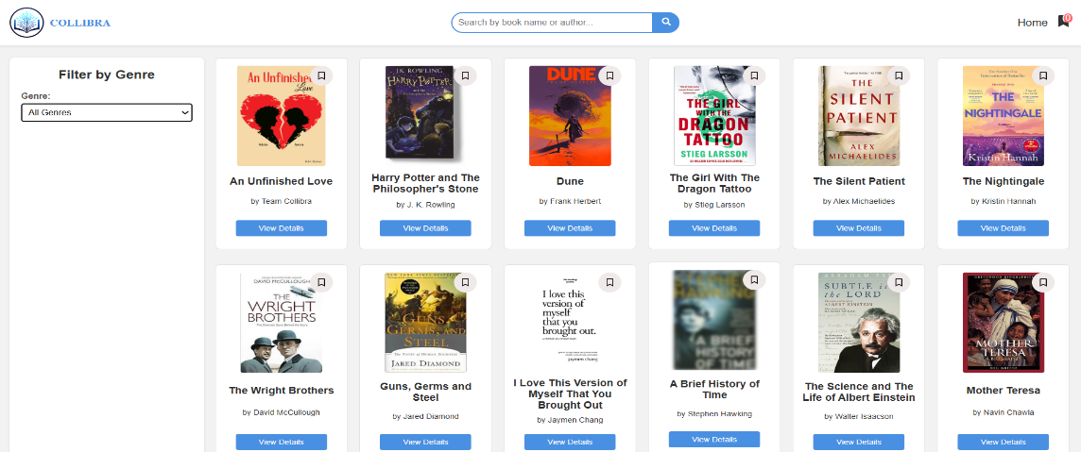

Figure 20: Explore Page

Chapter 6 | Limitations and Future Enhancements

6.1 Limitations
While the Collibra platform effectively delivers core BookHub functionalities and offers a user-friendly digital reading experience, certain limitations were observed during development and testing:

6.1.1 Limited User Authentication and Roles
- Current implementation lacks a full user registration and authentication system.
- There are no role-based access controls (e.g., differentiating between general users, authors, and publishers).

6.1.2 Basic Search Functionality
- Search is limited to titles/authors, lacking advanced filters (genre, publication date, ratings).

6.1.3. No In-App Reading Progress Tracking
- Users can read and download books, but their progress (e.g., last page read or reading history) is not tracked or saved.

6.1.4. File Storage Constraints
- Uploaded books and media are stored locally or on basic cloud storage; large-scale scalability (e.g., CDN delivery or file optimization) is not implemented.

6.1.5. No User Review or Ratings
- Readers cannot rate books or leave reviews, reducing community engagement.

6.2 Future Enhancements
To expand the scope and capabilities of Collibra, several enhancements are planned for future development phases:

6.2.1. User Authentication
- Adding login functionality for users to personalize their experience (e.g., saving bookmarks to a server rather than local storage).

6.2.2. Search and Recommendation System
- Integrate a search engine with filters for title, author, year, and keywords.
- Use AI-based recommendations based on user activity and preferences.

6.2.3. In-App Reading Experience
- Add a custom PDF viewer with bookmarks, notes, and reading progress tracking.
- Implement support for EPUB and HTML5-based interactive content.

6.2.4. Full Audiobook Integration
- Enable streaming of audiobooks with playback controls and download restrictions.
- Support multiple audio formats and player integration.

6.2.5. Analytics for Publishers
- Providing publishers with analytics dashboards to track book performance and user engagement.

6.2.6. Mobile App
- Developing a mobile application to make Collibra accessible on iOS and Android devices, further increasing its reach.

6.2.7. Multilingual and Accessibility Support
- Adding support for multiple languages to cater to a more diverse audience.

6.2.8. Admin Dashboard Analytics
- Provide usage statistics for admins and publishers (e.g., most read books, genre trends, user activity).
- Visual dashboards for data-driven decisions.

6.2.9. Subscription Model
- Offer premium memberships (monthly/yearly) for ad-free reading, exclusive books, or early access.
- Enable publisher revenue-sharing for paid content.

6.2.10. User Customization & Settings
- Dark/Light mode toggle for reading comfort.
- Adjustable font size, style, and spacing for better readability.

Chapter 7 | Conclusion
The Collibra project has successfully delivered a robust and user-centric digital Library platform that addresses the core challenges of accessing and managing literature in the arts and literature domain. By implementing a dual-interface system with an admin panel for book management and a user panel for exploration, Collibra ensures that both administrators and end-users have a seamless experience. The integration of real-time updates via WebSocket is a standout feature, allowing users to see new books, updates, or deletions on the Explore page within seconds of admin actions. This dynamic functionality significantly enhances user engagement, ensuring that readers are always up-to-date with the latest content.
The project’s success is also evident in its ability to cater to multiple stakeholders. For readers, Collibra provides an intuitive interface with features like genre filtering, bookmarking, and easy access to book PDFs, removing the barriers of physical and financial constraints. For publishers, the platform offers a digital marketplace to showcase their books, reaching a global audience and supporting additional services like event ticketing and library setup. Authors, particularly independent ones, benefit from increased visibility, as their works can be promoted through the platform’s catalog and event features.
From a technical perspective, Collibra demonstrates a well-architected solution. The use of modern technologies like React.js, Node.js, MySQL, and WebSocket ensures scalability, performance, and real-time communication. The UI design, with its consistent color scheme (e.g., Slate Blue #4A90E2 for buttons, Soft Coral #FF6B6B for bookmarks), enhances usability and provides a visually appealing experience. The project’s adherence to Agile methodology allowed for iterative development, ensuring that user feedback was incorporated at every stage.
Despite its achievements, there are opportunities for further improvement. Future enhancements could include:
- User Authentication: Adding login functionality for users to personalize their experience (e.g., saving bookmarks to a server rather than local storage).
- Mobile App: Developing a mobile application to make Collibra accessible on iOS and Android devices, further increasing its reach.
- Analytics for Publishers: Providing publishers with analytics dashboards to track book performance and user engagement.
- Multilingual Support: Adding support for multiple languages to cater to a more diverse audience.
In conclusion, Collibra stands as a testament to the power of digital solutions in transforming access to literature. It not only addresses the immediate needs of readers, publishers, and authors but also lays a strong foundation for future growth. By continuing to evolve and incorporate user feedback, Collibra has the potential to become a leading platform in the digital literature space, fostering a global community of readers and creators.

7.1 Achievements

7.1.1 Technical Accomplishments
- Scalable Architecture: The component-based React frontend (BookCard.js, Navbar.js) and Node.js backend with Express APIs ensure modularity and scalability, supporting seamless feature expansion.
- Responsive Design: Styled with Tailwind CSS and animations (e.g., floating navbar effects), Collibra delivers a consistent experience across desktop and mobile devices.
- Real-Time Updates: WebSocket integration via Socket.IO enables instant synchronization of admin updates (e.g., new books) to the explore.jsx page.
- Secure Data Handling: JWT-based admin authentication and SSL/TLS encryption protect user data, with MySQL ensuring reliable storage.

7.1.2 User Impact
- User-Friendly Interface: A minimal, intuitive UI with Slate Blue and Soft Coral colors simplifies navigation for browsing books and purchasing tickets.
- Efficient Content Access: Dynamic search and bookmarking features streamline content discovery, saving users time.
- Engaging Experience: Real-time updates and notifications for new content or events enhance user engagement.

7.2 Challenges and Learnings

7.2.1 Challenges
- Real-Time Sync: Implementing WebSockets for seamless admin-user updates was complex, requiring robust connection handling.
- Security: Balancing simple authentication (plain-text passwords) with secure practices posed challenges.
- UI Simplicity: Ensuring a feature-rich platform remained intuitive for non-technical users was difficult.

7.2.2 Learnings
- Team Collaboration: Effective coordination between frontend, backend, and database teams ensured a cohesive platform.
- Agile Approach: Iterative development facilitated rapid feature testing and refinement.
- User Feedback: Stakeholder input shaped features like search, aligning with user needs.

7.3 Future Directions
To enhance Collibra, the following improvements are planned:
- Advanced Features: Add user reviews, ratings, and social sharing for community engagement.
- AI Recommendations: Implement personalized content suggestions based on user preferences.
- Performance Optimization: Use caching (e.g., Redis) and query indexing for faster data retrieval.
- Security Upgrades: Introduce user authentication and two-factor authentication for enhanced protection.
- Mobile App: Launch a dedicated mobile app by late 2025 for improved accessibility.
- Collaboration Tools: Enable shared reading lists for collaborative use.
- Subscription Model: Introduce tiered subscription plans (e.g., Free, Premium, Pro) offering access to exclusive e-books.

Chapter 8 | References and Bibliography

8.1 References
- Al-Sudairy, M. A., & Al-Ghamdi, A. (2022). Digital libraries in the modern era: A case study on user-centered design. Journal of King Saud University - Computer and Information Sciences, 34(5), 1234-1240. https://doi.org/10.1016/j.jksuci.2021.08.005
- Borgman, C. L. (2015). Big data, little data, no data: Scholarship in the networked world. MIT Press.
- DeLone, W. H., & McLean, E. R. (2003). The DeLone and McLean model of information systems success: A ten-year update. Journal of Management Information Systems, 19(4), 9-30. https://doi.org/10.1080/07421222.2003.11045748
- Field, A. (2018). Discovering statistics using IBM SPSS Statistics (5th ed.). SAGE Publications.
- Kumar, R., & Singh, P. (2023). Real-time web applications using WebSocket: Performance and scalability analysis. Journal of Information Technology Research, 16(2), 45-58. https://doi.org/10.4018/JITR.2023020104
- Lynch, C. A. (2020). The future of digital libraries: Challenges and opportunities. Annual Review of Information Science and Technology, 54(1), 89-112. https://doi.org/10.1002/aris.2020.1440540106
(Discusses trends in digital libraries, applicable to Collibra’s evolution from an e-commerce platform to a comprehensive eLibrary.)
- Pusher, S., & Taylor, M. (2019). WebSocket: Lightweight client-server communications. O’Reilly Media.
- Pinterest: https://www.pinterest.com/ (Books Cover Page)

8.2 Bibliography
The bibliography includes additional sources that informed the project. These sources provide background on topics like real-time web applications, UI design, and Agile practices.
- Beck, K., Beedle, M., van Bennekum, A., Cockburn, A., Cunningham, W., Fowler, M., Grenning, J., Highsmith, J., Hunt, A., Jeffries, R., Kern, J., Marick, B., Martin, R. C., Mellor, S., Schwaber, K., Sutherland, J., & Thomas, D. (2001). Manifesto for Agile software development. https://agilemanifesto.org/
- Caulfield, J. (2024, January 17). How to cite a book in APA style: Format & examples. Scribbr. https://www.scribbr.com/apa-examples/book/
- Date, C. J. (2004). An introduction to database systems (8th ed.). Pearson.
- Nielsen, J. (1994). Usability engineering. Morgan Kaufmann.
- Pressman, R. S. (2014). Software engineering: A practitioner’s approach (8th ed.). McGraw-Hill Education.
- Streefkerk, R. (2024, January 17). Ordering works on the APA reference page. Scribbr. https://www.scribbr.com/apa-style/ordering-references/
- University of California, Berkeley, Computer Science Department. (n.d.). POSTGRES white papers and technical reports. https://dsf.berkeley.edu/papers/

